**“EMPLOYEE INSURANCE CLAIM ANALYSIS”**

**INPATIENT DATA**

**BUSINESS PROBLEM:**

* To analyze the ways to increase Benefits in Insurance Schemes/Policies in such a way, that can help to provide better benefits to Employees and Insurance Company in Malaysian market.

**BUSINESS OBJECTIVE/BUSINESS CONSTRAINTS:**

* The objective is to find out all possible ways to improve the benefits, which a company can come up for employees, so that they can provide better facilities to employees.
* The analysis will be on past Malaysian Insurance Claim records, which were claimed in Financial Year 2018 & 2019.

(*This sample data was created with the objective to perform various analyses and to provide best possible ways to improve business problem.*)

**DATA COLLECTION:**

* The collection of data is done while keeping in mind that, Data collection in healthcare, allows health systems to create holistic views on:
  + Patients,
  + Personalize Treatments,
  + Advance Treatment Methods,
  + Improve Communication between Doctors and Patients,
  + Enhanced Health Outcomes.
* The collection of data is done on the basis of past records which were claimed in financial year 2018, 2019.
* The data comprises of all Malaysian Hospitals, with the list of Diagnosis in individual hospitals and the amount claimed for those diagnoses.

**DATA DICTONARY:**

* Sample data is divided in 2 separate sheets, which comprises of 250 Claimed records in one sheet and 230 Claimed records in another sheet of financial year 2018 & 2019 with total 9 Labels i.e. (Claim ID, Plan Code, Relationship, Admission Dates, Discharge Dates, Hospital Names, Diagnoses, Claim Total Bill Amount, Claim Total Paid Amount) in each sheet.

**EDA:**

**MULTIVARIATE ANALYSIS:**

* In FY-2018 & FY-2019, for doing an analysis, we have considered 6 columns out of 9 columns i.e. (Plan Code, Relationship, Hospital Names, Diagnoses, Claim Total Bill Amount).

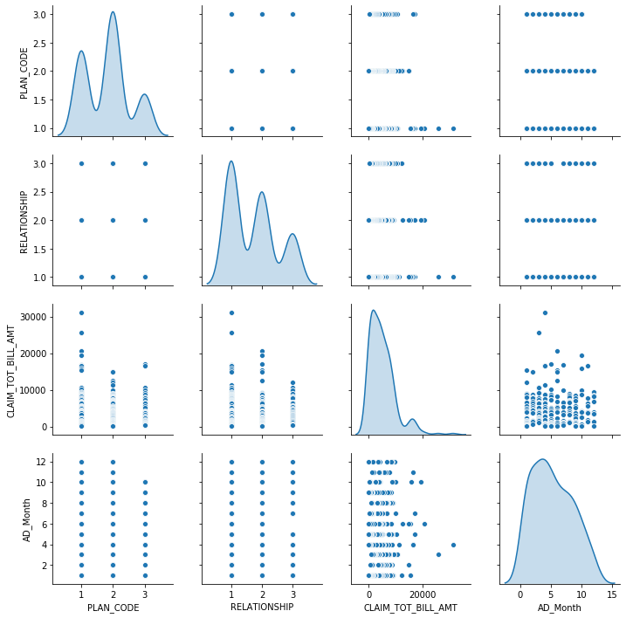

FY2018

* The above chart is of FY 2018 and we can see that:
  + In Plan Code, there are 3 types of Plans i.e. Plan 1, Plan 2, Plan 3 and the maximum Plan which was preferred by employees was Plan 2.
  + In Relationship, there are 3 types of Relations which are described here i.e. Employee (Themselves), Spouse (Wife/Husband), Children. From the chart we can say that the maximum claims which were claimed in FY18 were for Employees (themselves).
  + In Claim Total Bill Amount, from the chart it is clear that the cost of treatments, which were claimed in FY18 were mostly, in the range between 0/- to 20,000/-.
  + In Admission Month, we can say that maximum treatments which were claimed in FY18 were in First & Second Quarters of FY18-19.

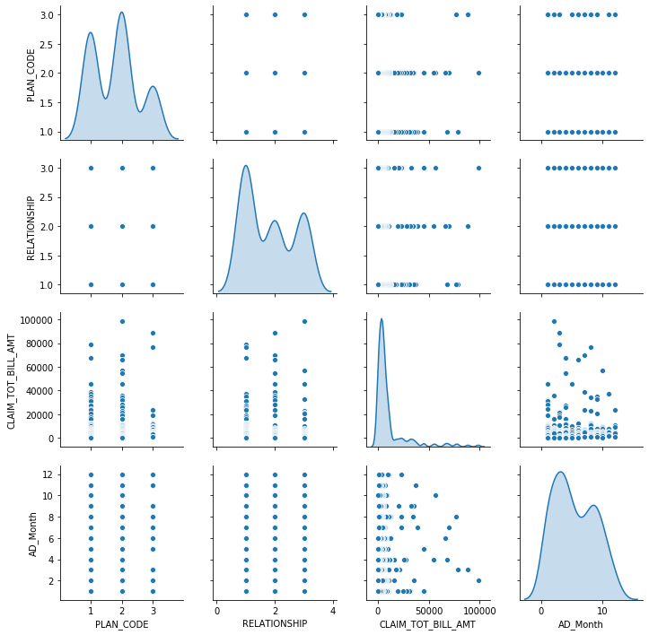

FY-2019

* The above chart is of FY 2019 and we can see that:
  + In Plan Code, there are 3 types of Plans i.e. Plan 1, Plan 2, Plan 3 and the maximum Plan which was preferred by employees was Plan 2.
  + In Relationship, there are 3 types of Relations which are described here i.e. Employee (Themselves), Spouse (Wife/Husband), Children. From the chart we can say that the maximum claims which were claimed in FY19 were for Employees (themselves).
  + In Claim Total Bill Amount, from the chart it is clear that the cost of treatments, which were claimed in FY19 were maximum, in the range between 0/- to 25,000/-.
  + In Admission Month, we can say that maximum treatments which were claimed in FY19 were in First & Third Quarters of FY19-20.

**COMPARISON ANALYSIS:**

* In FY-2018 & FY-2019, we have come across that:

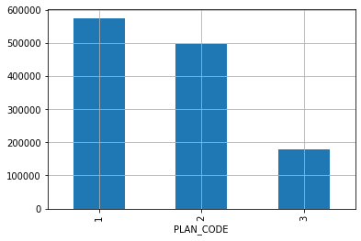 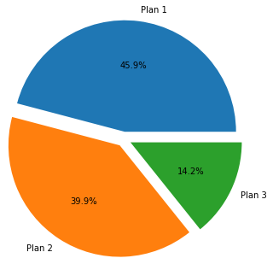

FY-2018

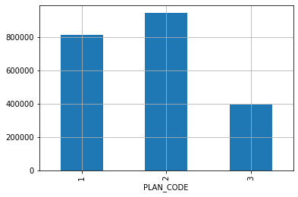 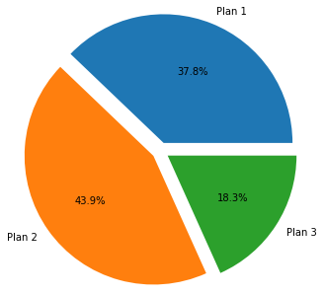FY-2019

* The Plans with maximum Total Bill Amounts which were claimed in FY18 & FY19 were Plan 1 & Plan 2, as they comprises of maximum number of Hospitals and Diagnosis which are covered under these 2 Plans.
* There should be increase in maximum sum insured amount i.e. 10 lakhs for both Plan 1 & Plan 2 because as we can see that the total claim amount has crossed above 5 lakhs in both 2018 & 2019, but in case of Plan 3 there should be revise in maximum sum insured amount i.e. 5 lakhs because total claim amount is less than 5 lakhs.

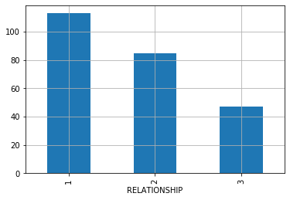 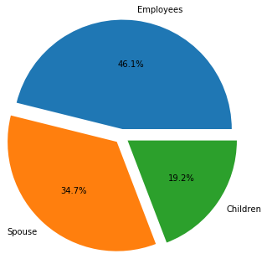

FY-2018

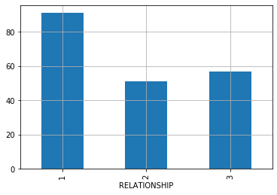 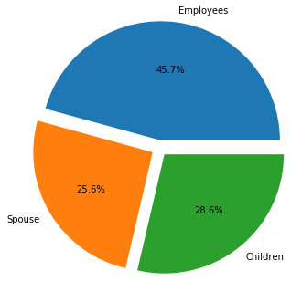

FY-2019

* The above charts explain us that, the maximum number of time the relation who took maximum claims in FY18 & FY19 was for Employee themselves in comparison to their family members. But in case of Spouse & Children the ratio is almost 50% for both the financial years, which means the main focus towards the designing of Plans should be not only for Employees but, for all the family members.

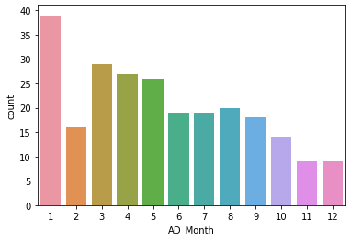 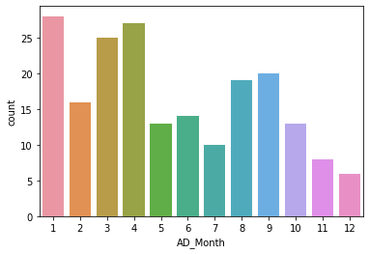

FY-2018 FY-2019

* We can say that maximum treatments ratio which was claimed in FY18 & FY19 were, in First & Second Quarters of FY18-19 whereas, maximum treatments ratio which was claimed in FY19 were, in First & Third Quarters of FY19-20.

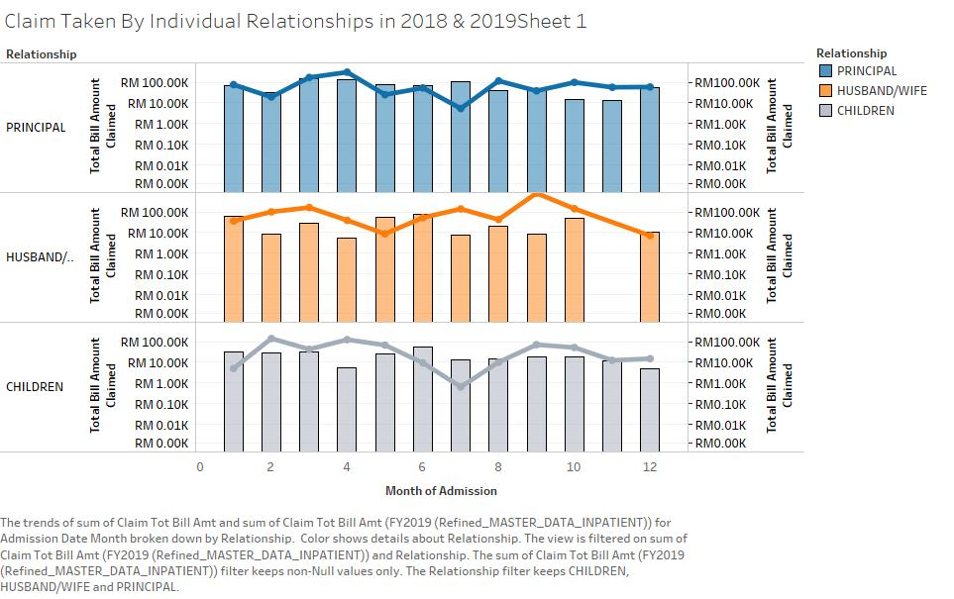

* The above chart explains about the consolidated Insurances, claimed by individual Relationships in each month.
* Bars explain the total claim amount taken each month in FY18 and the Line chart above bar explains the claim amount taken each month in FY19 by each individuals (i.e. Principal (Employee), Husband/Wife (Spouse), Children).
* The chart explains us that the claim ratios are less fluctuated each month in comparison to Spouse & Children. This means the insurance claims are more in quantity and continuous every month in case of Employees themselves than family members.

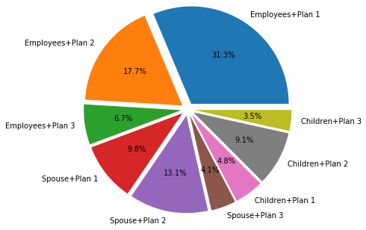 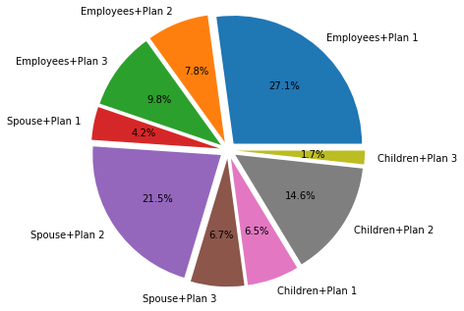

FY-2018 FY-2019

* This comparison pie chart explains that which Relation, in which Plan has claimed maximum in FY18 & FY19 and from the chart we can say that Maximum Claim ratios in FY18 & FY19 are by Employees in Plan 1 & by Spouse & Children in Plan 2. Therefore we can say that Plan 1 can be more Employees centric whereas Plan 2 can be more Family centric.
* Analysis concludes that there should be increase in maximum sum insured limit for Plan 1 & Plan 2, as it covers most of the Hospitals , Diagnosis and it is observed that Plan 1 & 2 are more preferred Plans for both Employees & their Family.

**CONCLUSION:**

* **Check the distribution of Hospitals & diagnosis into 3 categories are correct or there can be more or less number of distributions into 2 Plans or more than 4 Plans?**

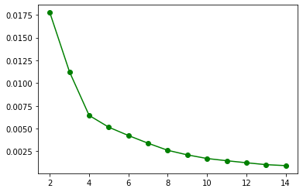

* We have performed K-Means clustering to check the distribution of data. As the above graphs explains that the distribution of data is divided into 3 categories i.e. into 3 Plans. This helps us to understand the numbers Plans we can consider on the basis of 2018-19 data and under which plan we can include or exclude Hospitals & Diagnosis to improve the Claims.
* **If the person wants to visit some affordable hospital and look for the best hospitals with reasonable cost for treatment, then can we suggest the list of hospitals he/she can visit for treatment?**
* Yes, we can suggest the list of Hospitals where the person can visit for the treatment on the basis of last Hospital he/she visited for treatment. To perform this recommendation we have considered 1 Hospital i.e. “Hospital Melaka” and we will be looking for the recommendations on the basis of this Hospital and people who visited other hospitals where the same treatment can be cured.
* First we found the list of Hospitals from where we received claims in 2018-19.

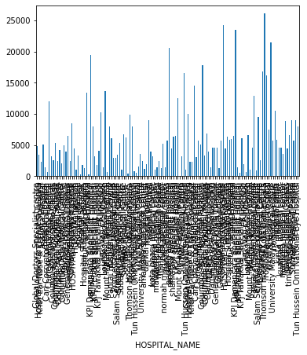

* Then we searched for number of times all hospitals visited to provide the best hospitals.

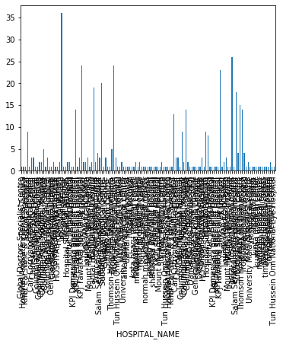

* Now we have considered 1 Hospital i.e. **"Hospital Melaka"** to check whether we can provide the list of Best Hospitals with affordable cost for treatments.

The List of Best Hospitals and related to Hospital Melaka are as follows:

Assunta Hospital -0.799897

Carl Corrynton Medical Centre -1.000000

Chinese Maternity Hospital 1.000000

Columbia Asia Hospital Taiping 0.873012

Columbia Asia Medical Centre 1.000000

Gleneagles Medical Centre -1.000000

Hospital Melaka 1.000000

Hospital Sultanah Bahiyah 1.000000

KPJ Kajang Specialist Hospital 0.972502

KPJ Tawakkal Specialist Hospital 0.530461

Lam Wah Ee Hospital -1.000000

Lourdes Medical Centre -1.000000

Pantai Hospital Kuala Lumpur 0.611186

Pentai Hospital Group -1.000000

Salam Senawang Specialist Hospital -1.000000

Subang Jaya Medical Centre 0.836590

Sunway Medical Centre -1.000000

Thomson Hospital Kota Damansara 0.957582

Tropicana Medical Centre 0.486567

* **If the person suffers from some particular diseases, then can we suggest the list of diseases that have chances that a person can face in future, this will help him/her to select which plan is best for them?**
  + Yes, we suggest prospect diseases which a person can face in future depending on the diseases he/she faced in past. Steps to get recommended diseases are as follows:
    - First we will find the list of hospitals from where particular person treated his last disease and at what amount.

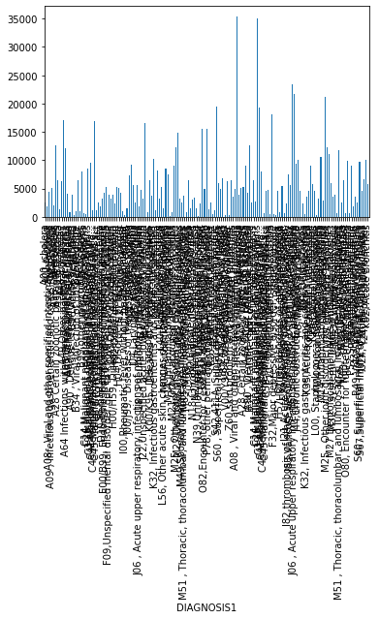

* Then we will find the list of diseases which most of the people claimed in 2018-19.

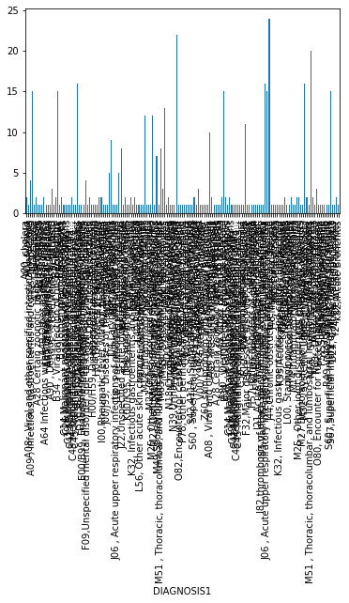

* Now we have considered 1 Disease i.e. **"N63, Unspecified lump in breast"** to check whether we can provide the list of Diseases that particular person can have as prospect.

The List of Best Hospitals and related to N63, Unspecified lump in breast are as follows:

A08 , Viral and other specified intestinal infe... -0.521172

A09 , Infectious gastroenteritis and colitis, u... 1.000000

A15 Tuberculosis 1.000000

A90 , Dengue fever [classical dengue] 0.983130

B34 , Viral infection of unspecified site 0.283739

C50 , Malignant neoplasm of breast 0.986416

E10 , TYPE 1 DIABETES MELLITUS -0.887323

J01 , Acute sinusitis 1.000000

J03 , Acute tonsillitis 1.000000

J18 , Pneumonia, unspecified organism -1.000000

J21 , Acute bronchiolitis 0.960935

K40,Inguinal hernia -1.000000

M13 , Other arthritis 0.143703

M25 , Other joint disorder, not elsewhere class... -1.000000

M32 , Acute bronchiolitis -0.953321

M51 , Thoracic, thoracolumbar, and lumbosacral ... 0.026564

M63, Viral infection of unspecified site 1.000000

M65 , Synovitis and tenosynovitis 0.129774

N00, acute nephritic syndrome 1.000000

N63 , Unspecified lump in breast 1.000000

S60 , Superficial injury of wrist, hand and fin... -1.000000

* **If a person is confused to select which plan is best for him/her or which plan is best for his/her family or which plan he/she should select on the basis of hospital or disease he or his family can have, then we provide suggestion to individual?**
* To help to select the best plan on the basis of various perspectives, we have calculated the result on the basis of association between the options selected by different employees in FY2018-19.

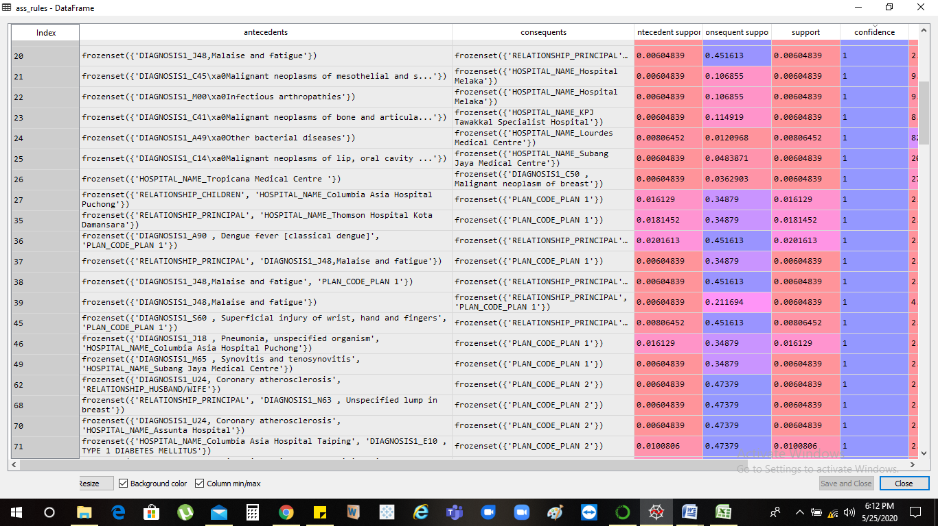

The above list explains the relation between options which will help an individual to decide which best plan suits his/her requirements.

Eg:

* + On Index 27, we can say that, if an employee is looking for insurance which can help to cover diseases for his/her family then, from the chart it is very clear that if there is a particular disease which is happening to children, and employee is looking for hospitals which is close to him for the treatment then, he can opt for Plan 1 which is recommended and will also help him to cover the cost of that treatment.

This way we can improve the claim ratio from Company’s perspective and not only that this will help employees to generate royalty, as it will serve them with better benefits as per their requirements.